- Find posted GL entries that need to be posted again after you reversed.
  - Must be from journals and not documents.
- Copy and paste into Excel.
- Now navigate to the General Journal menu option in Nav.
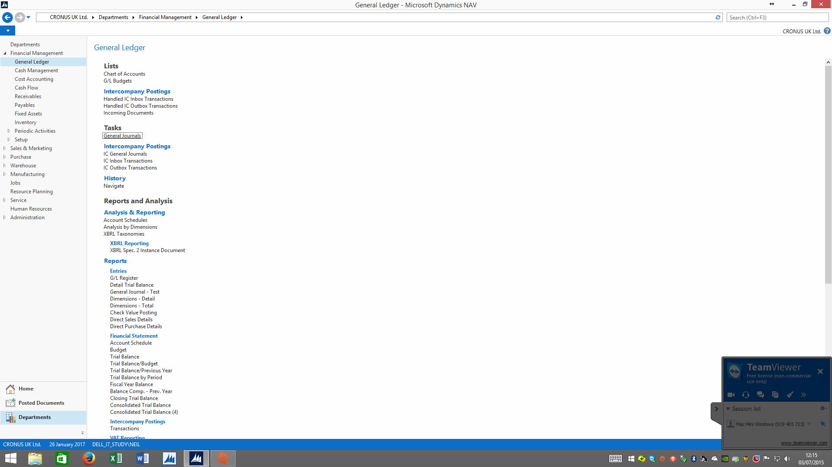

- Set the column order as follows using the Show Column option:
  - Posting Date
  - Doc Type – not necessary for this type of copying.
  - Doc Number – not required (do NOT include) of the journal batch as a number series assigned.
  - Account Type – always G/L Account.
  - Account No.
  - Description.
  - Department Code.
  - Amount.
- These are just examples of what to include and assume no VAT accounting required.
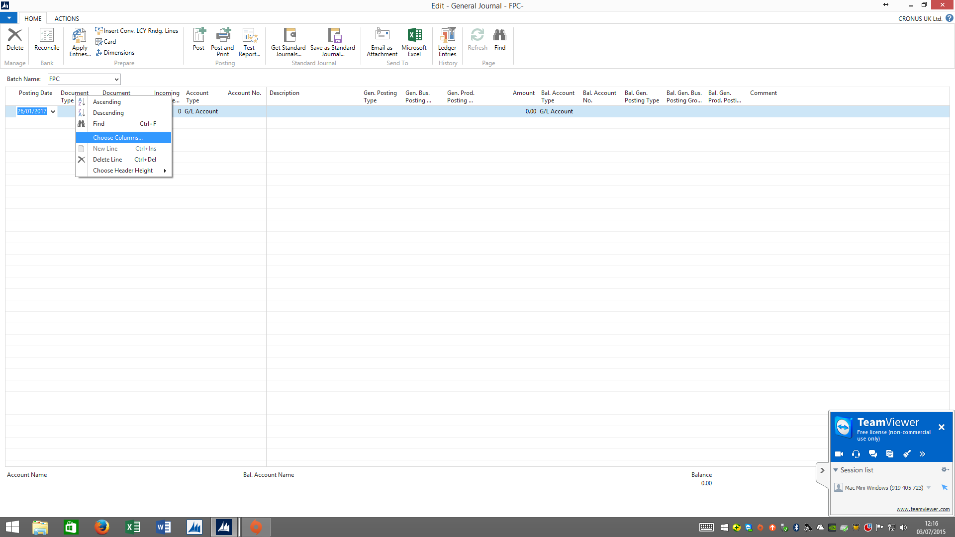
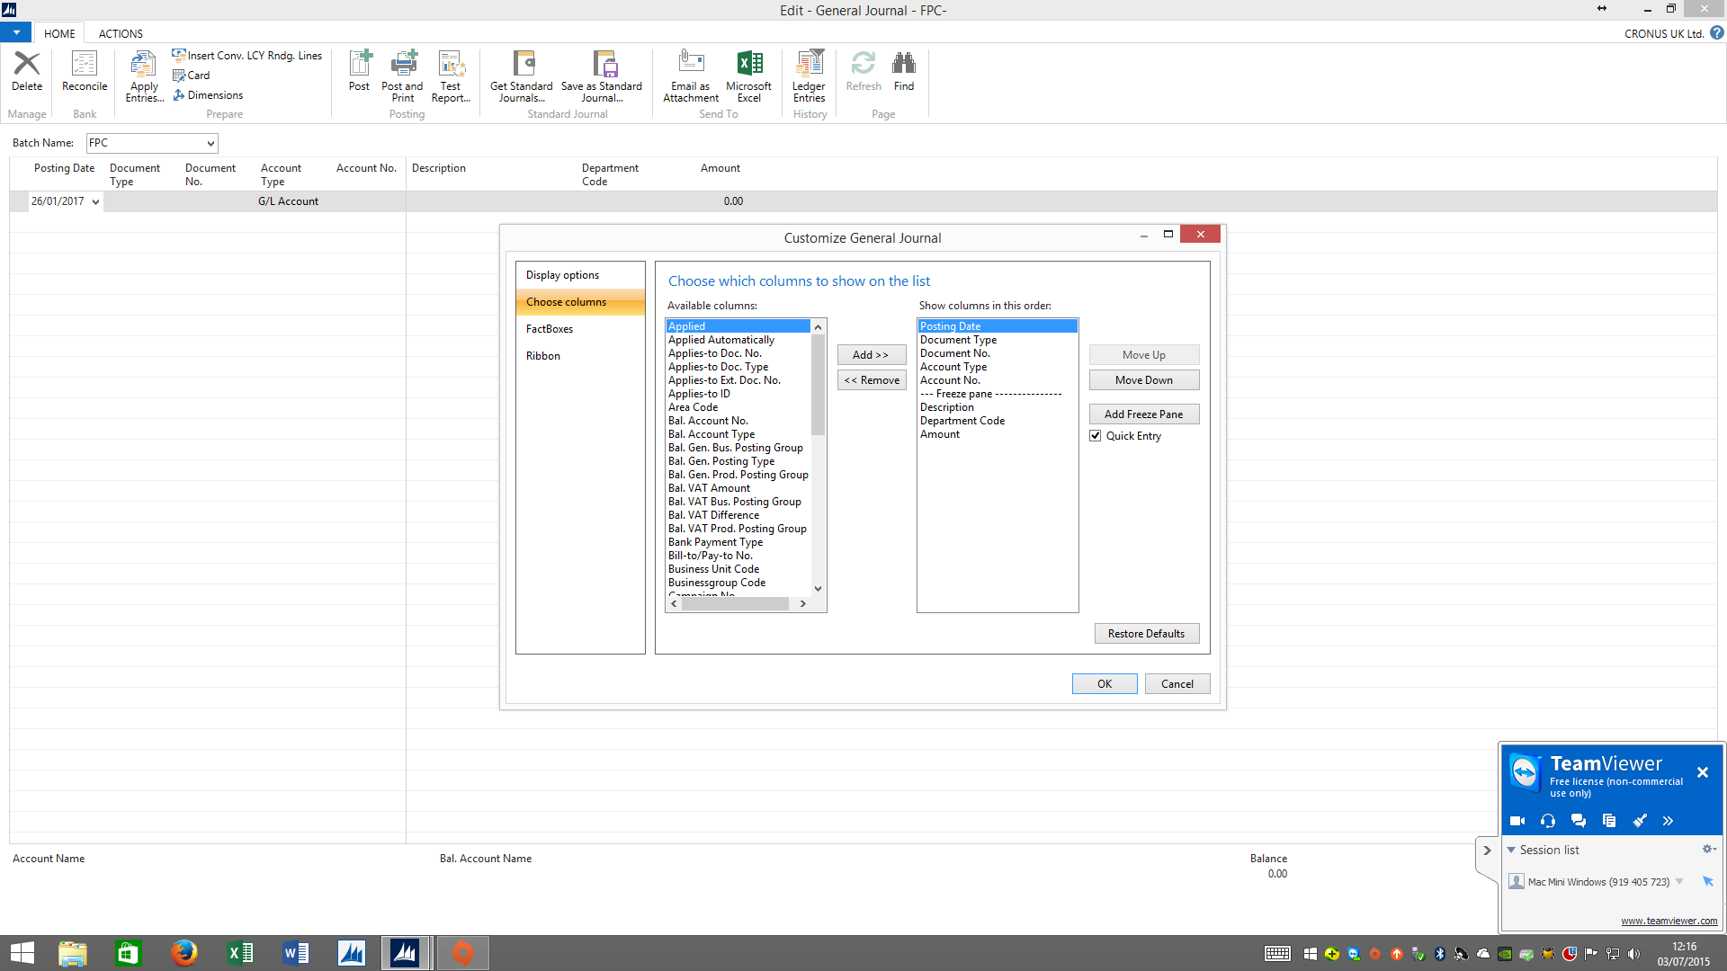
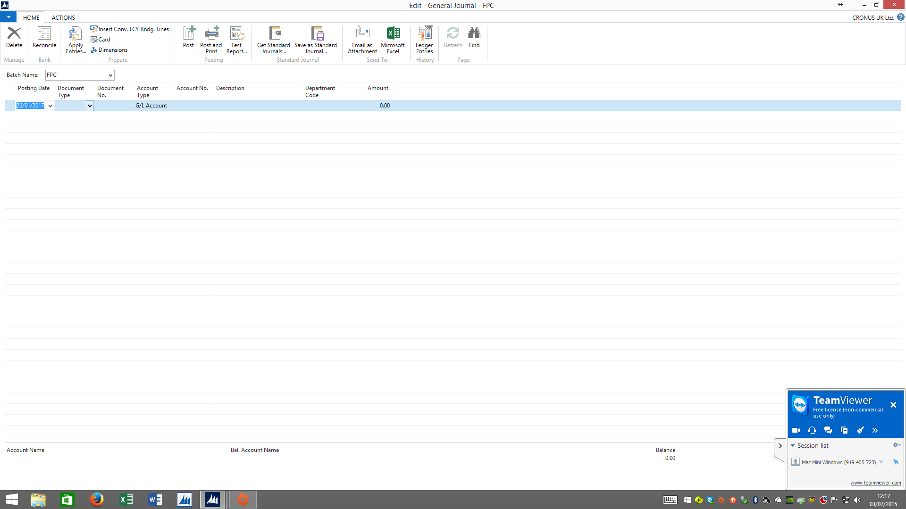

- Create a dummy first line.
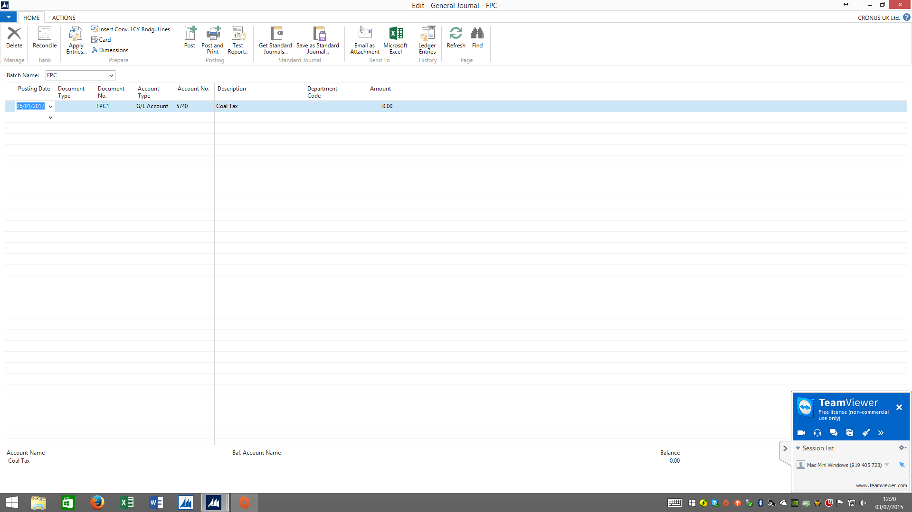
- Copy and paste into excel –same file as above.
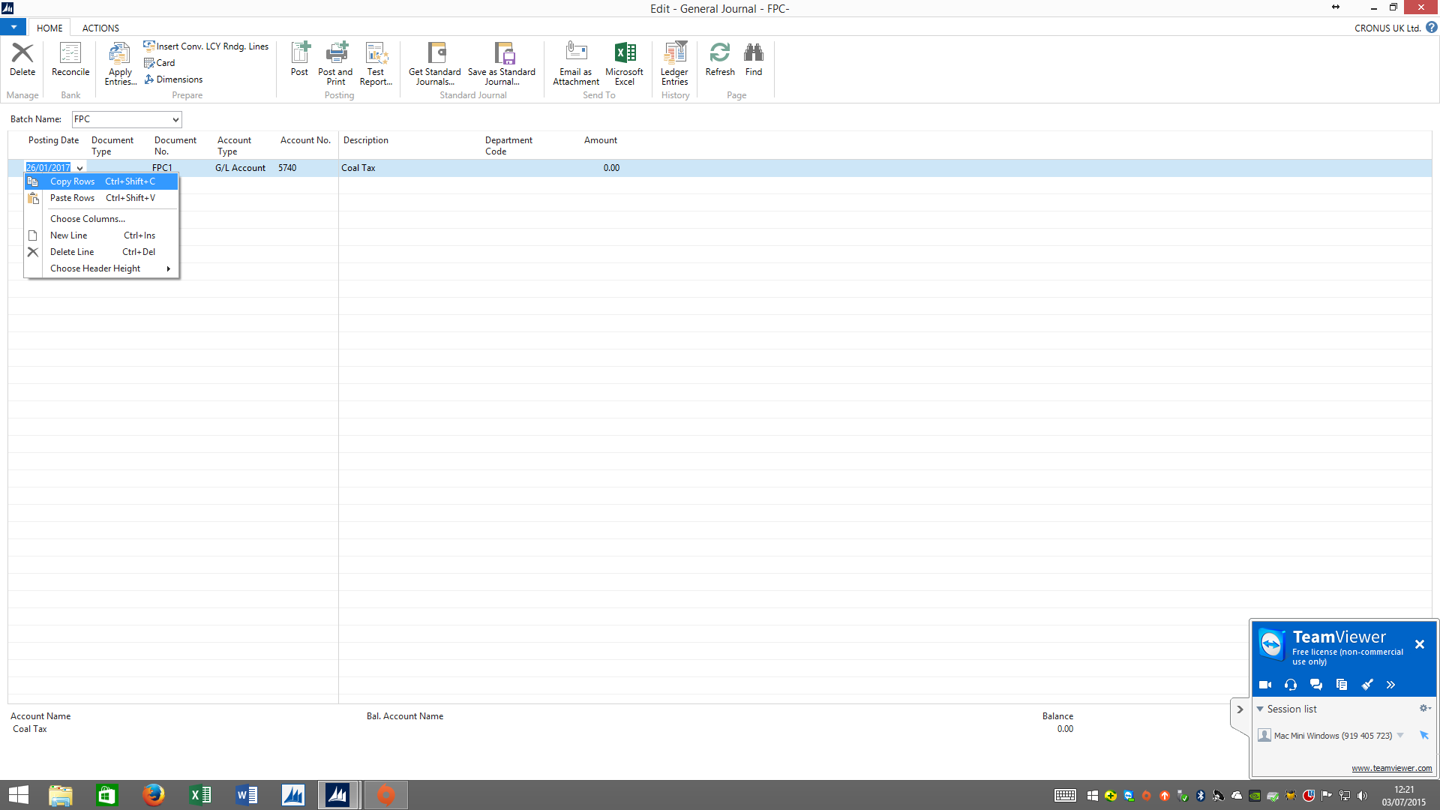
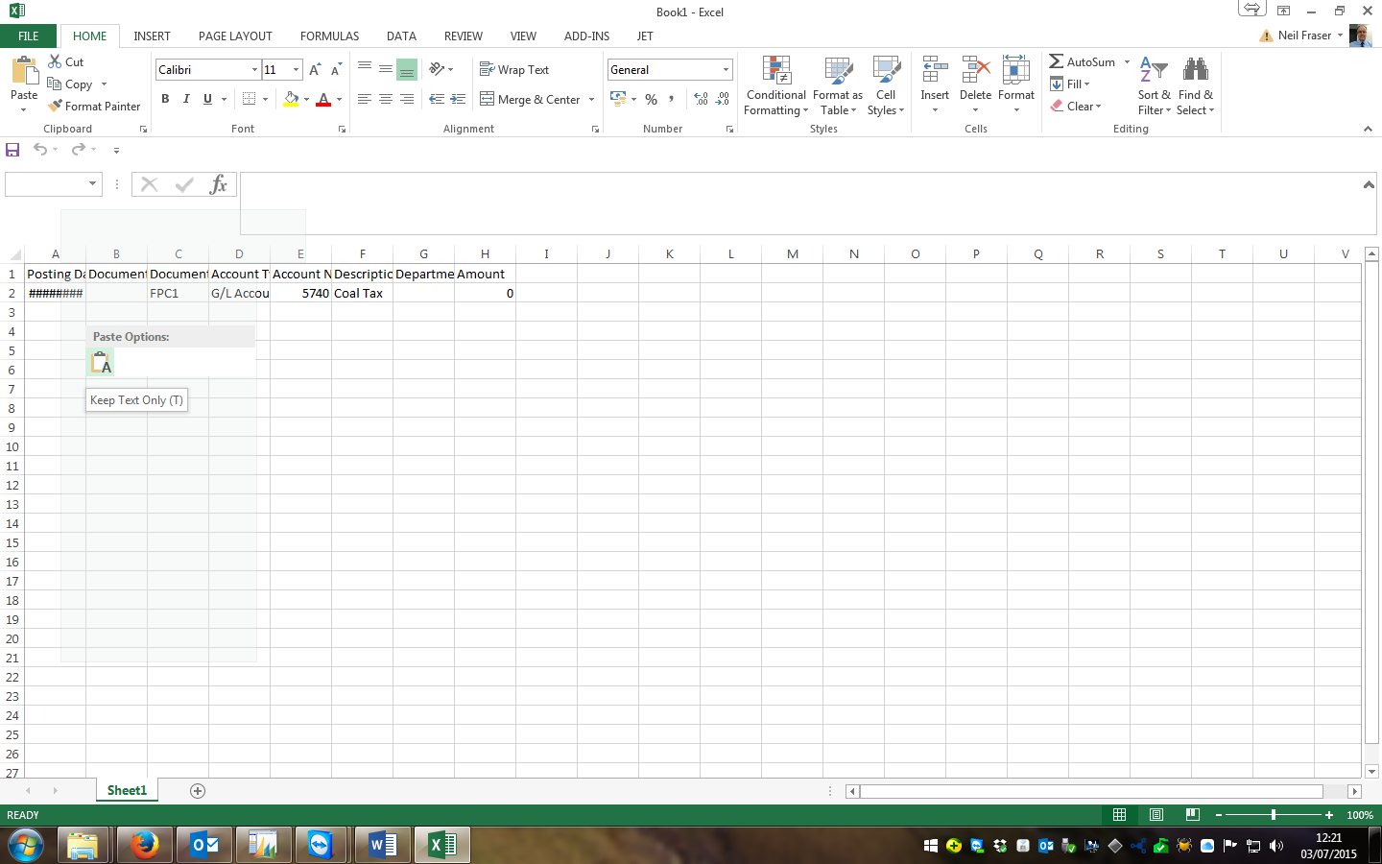
- Delete dummy line.
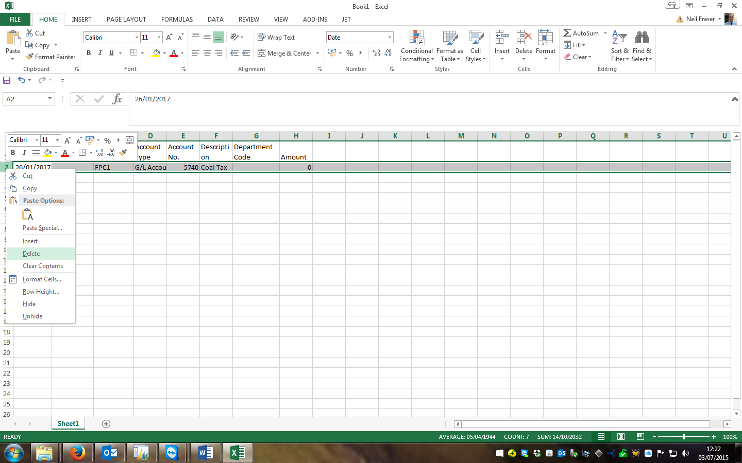
- Use formulas to pull through data into general journal format from posted entries tab to journal tab.
  - You MUST keep the same column order.
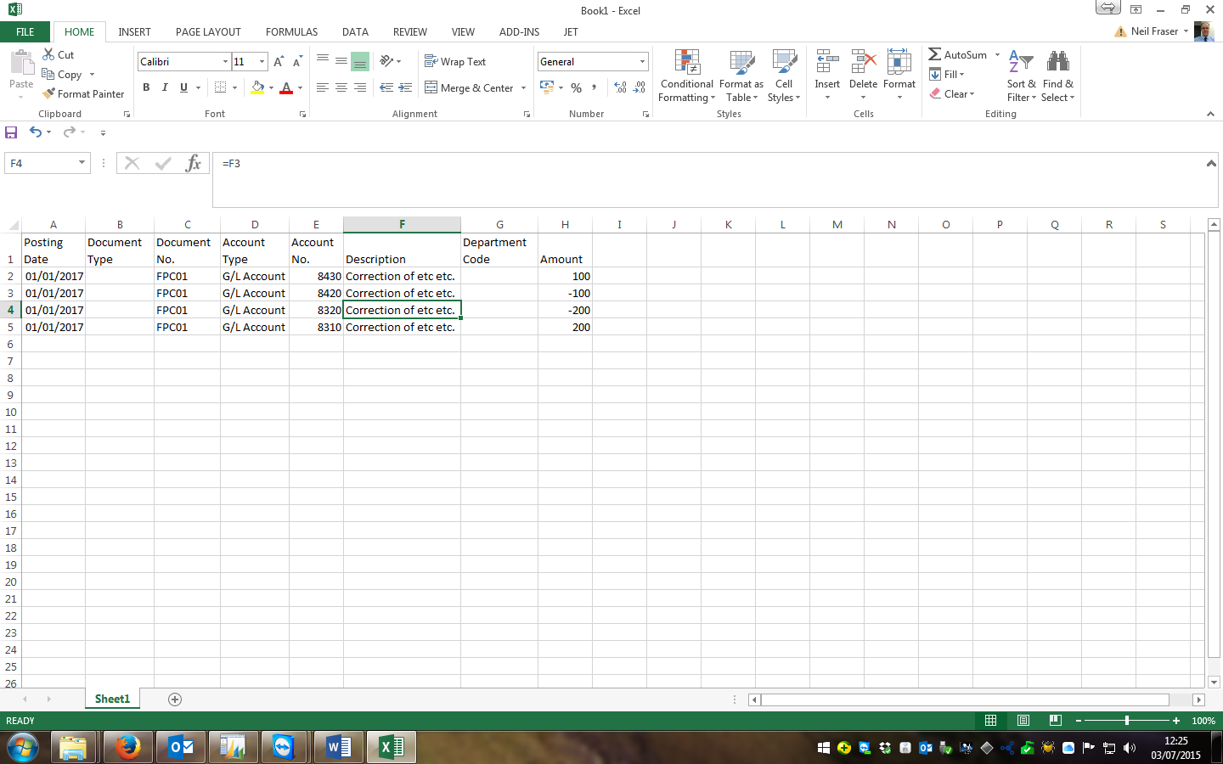

- Highlight lines to copy.
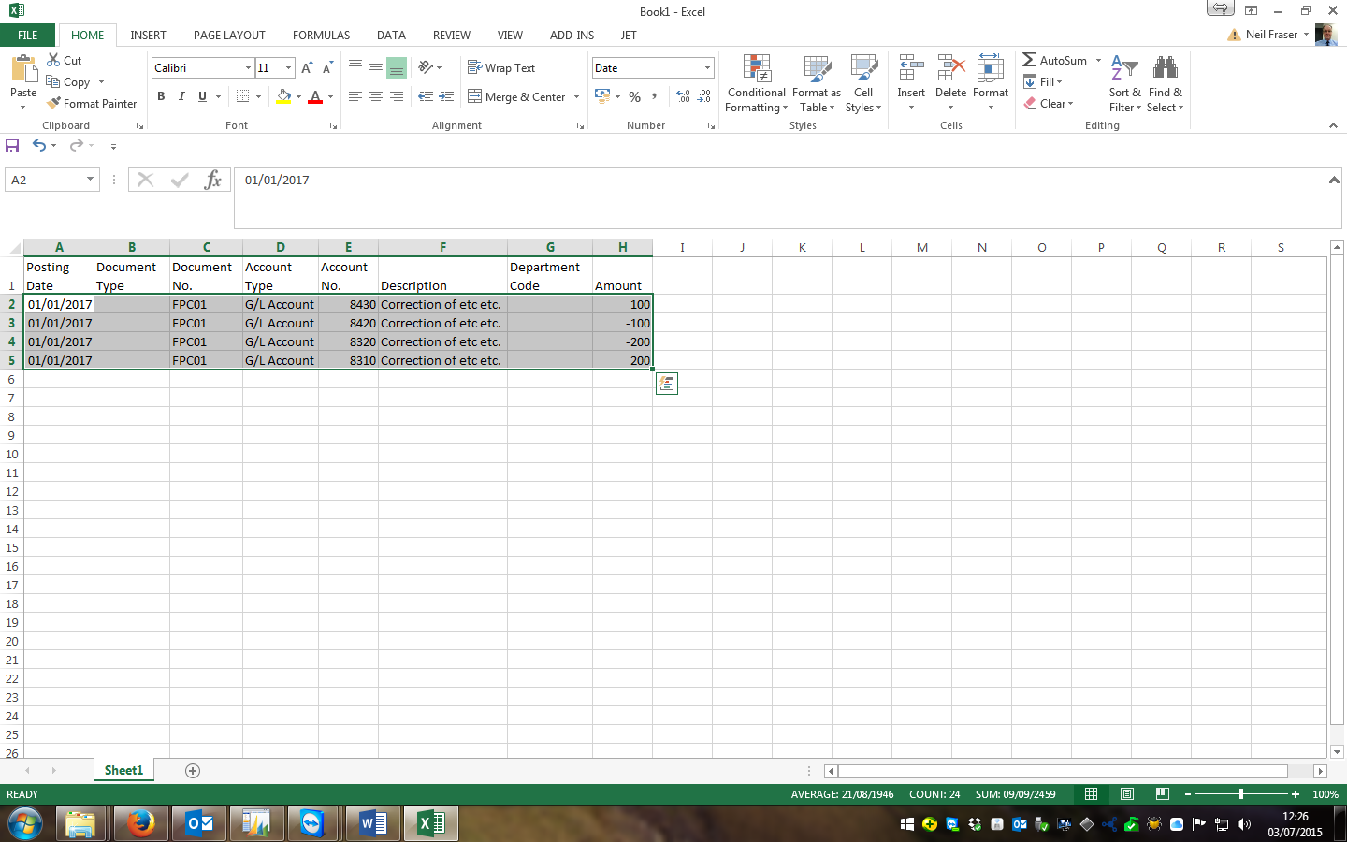
- Right mouse click and Copy.
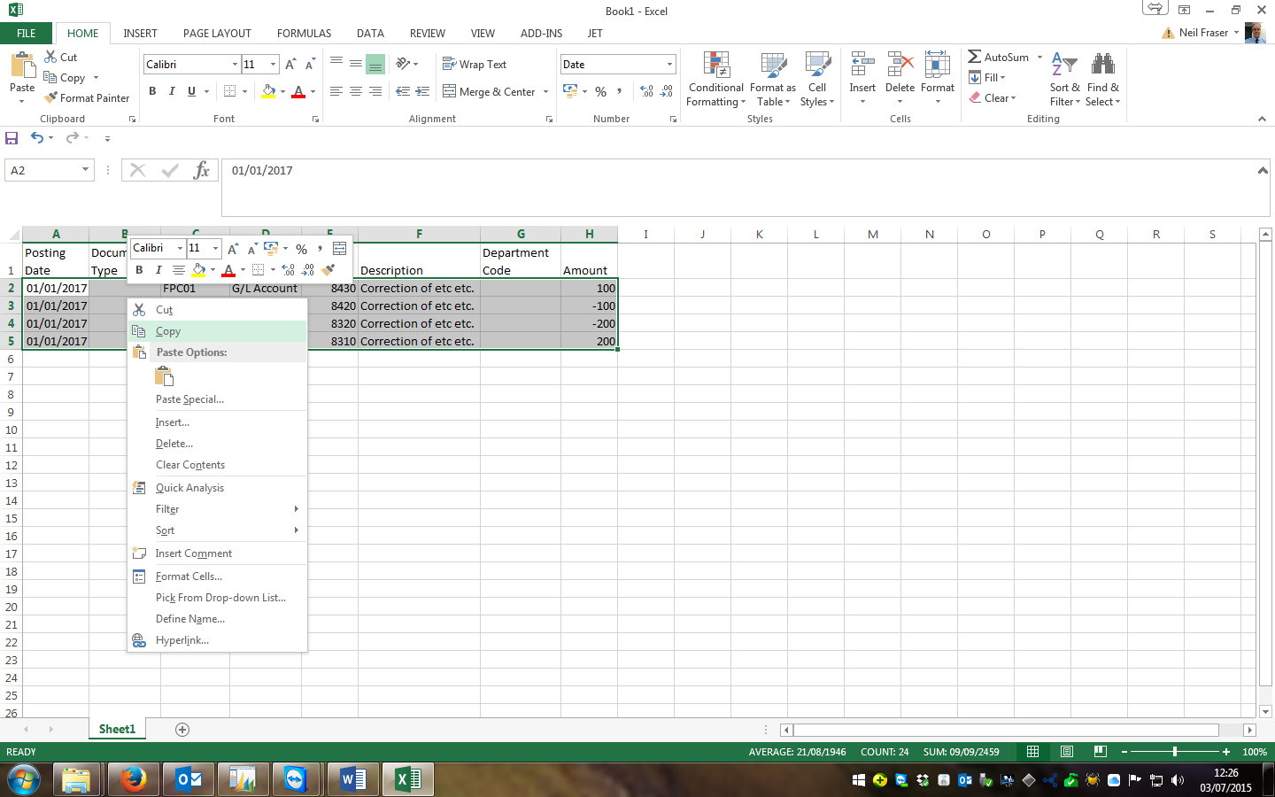
- Now show the General Journal in Nav.
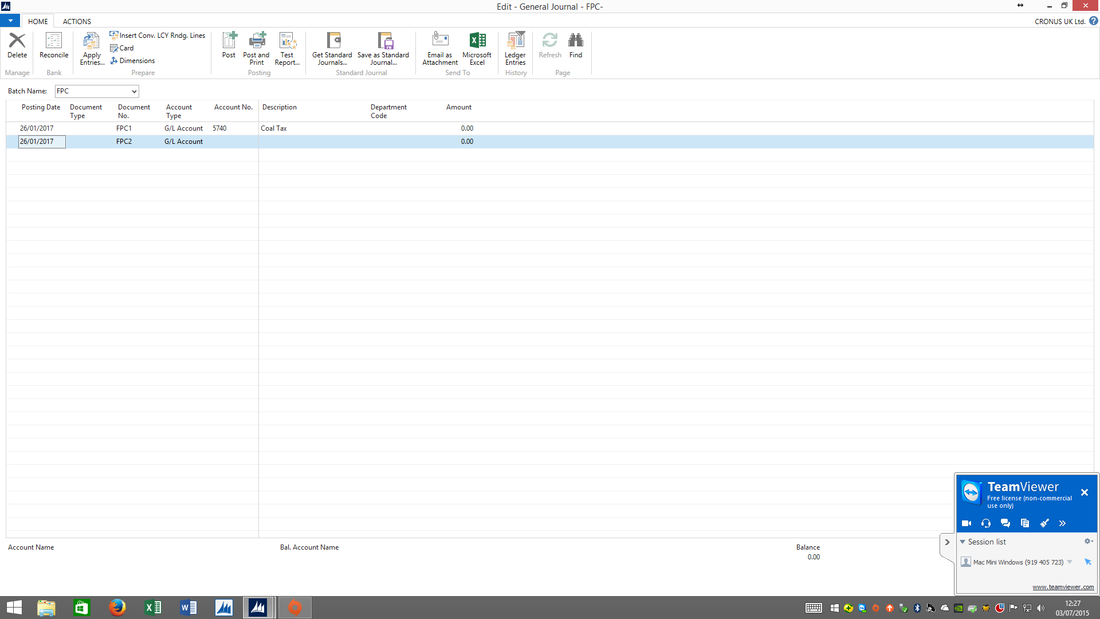
- Select first available blank line, right mouse click and Paste Rows.
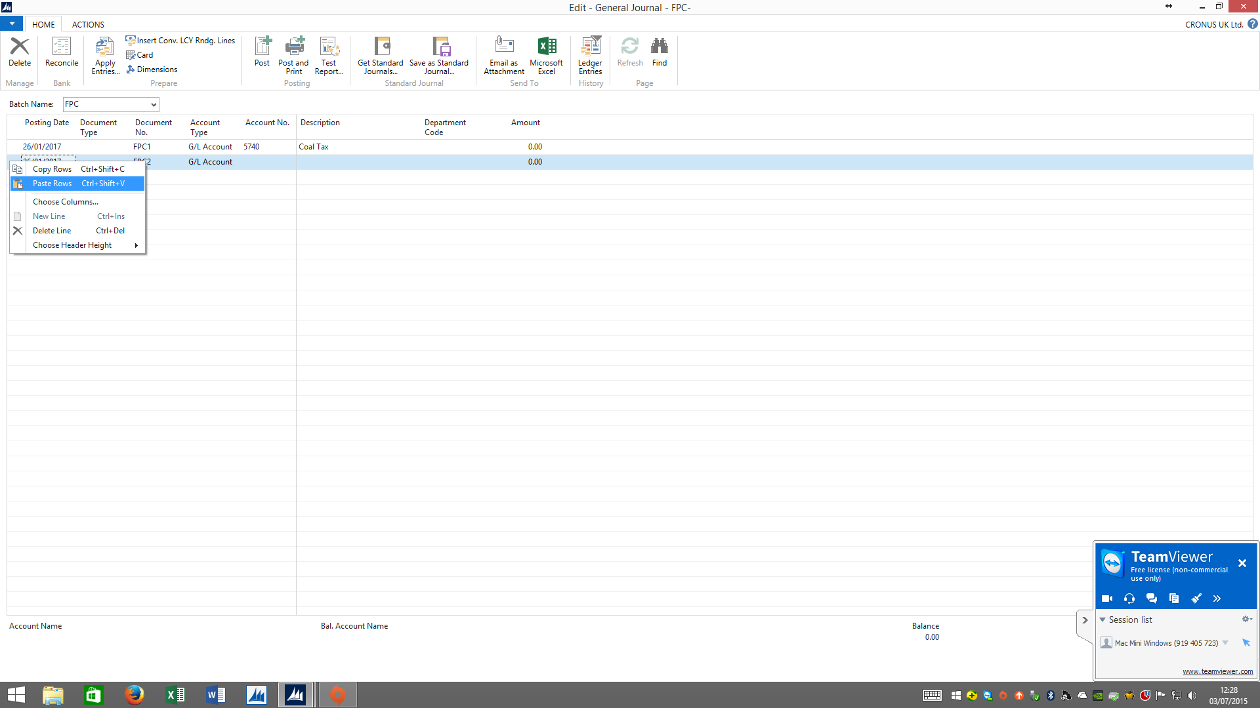

- Any errors will be shown or will stop the process. But if all ok the journal will have more lines.
