Contents
Introduction 2
Pre requisites 2
Set up process 3
VAT report configuration 3
VAT report setup 4
VAT period set up 7
Next….. 8

Introduction
This document describes the process for setting up Dynamics Nav for MTD VAT. Other documents will follow to show how to register Dynamics Nav for transmission of VAT return data to HMRC under MTD and how to complete VAT return submissions under this new process.

Pre requisites
- This only applies to Dynamics Nav versions 2015, 2016, 2017, 2018 and 365 Business Central. No other versions are supported by Microsoft and therefore no other versions will be approved for use by HMRC.
- The above supported versions of Dynamics Nav will need to have the following cumulative updates applied – newer updates can be applied as they will (by definition) include the relevant MTD VAT updates):
  - Nav 2015 – CU50
  - Nav 2016 – CU38
  - Nav 2017 – CU25
- Nav 2018 and Nav 365 Business Central already include MTD VAT and so do not need any specific cumulative update to be applied.
More details on MTD for VAT are available at https://www.dynamicsnavukhelp.co.uk/mtd-vat/.
Please note all the screen shots below are taken from our version of Dynamics Nav 2017 for our books.

Set up process
Before you can use MTD VAT you need to complete some setups.

VAT report configuration
- Navigate to Departments, Financial Management, Setup, General.
- Select VAT report configuration.
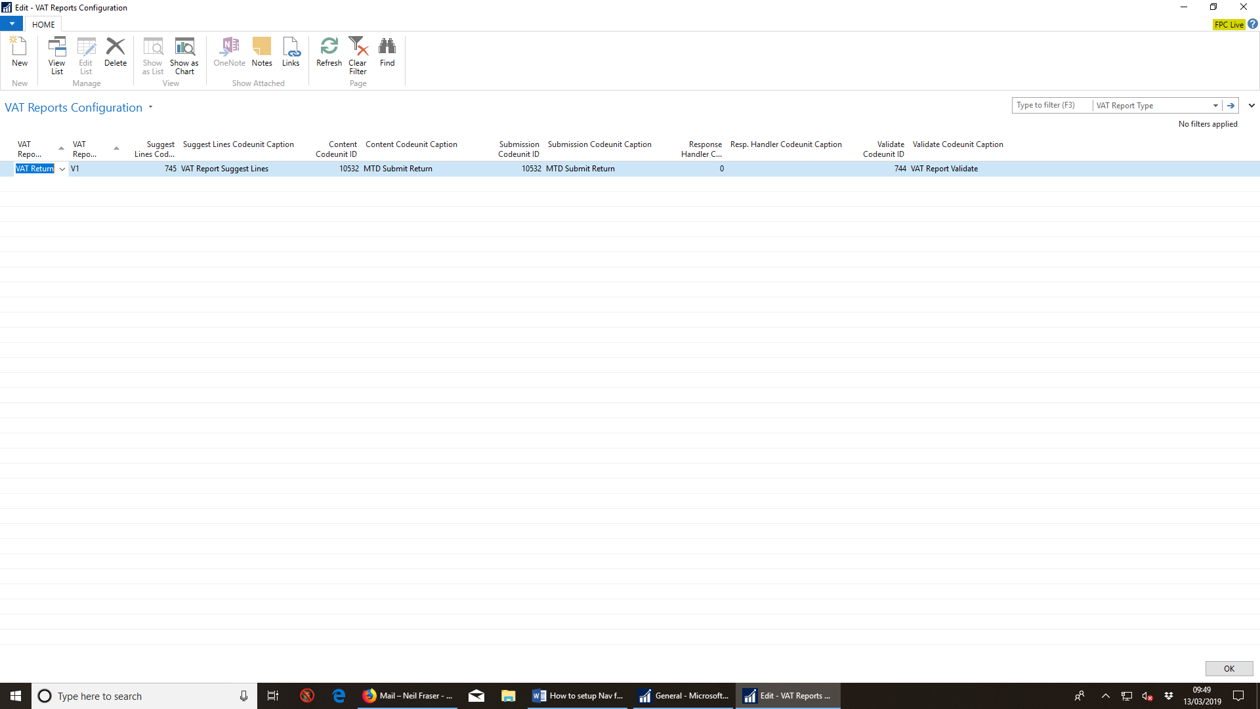
- Complete as above. For different versions of Dynamics Nav the codeunit references may be different believe it or not. This is certainly the case when comparing Dynamics Na 2017 to 2018.

VAT report setup
- Navigate to Departments, Financial Management, Setup, General.
- Select VAT report setup.
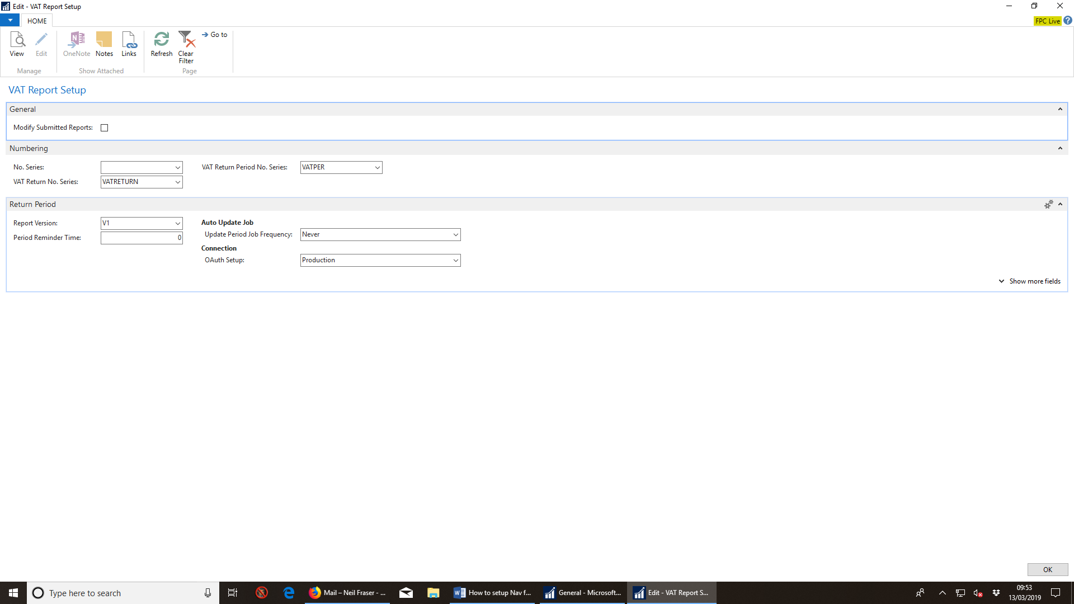

- Complete the fast tab Numbering as follows:
  - No. Series – leave blank.
  - VAT return number series
    - Assign a number series which will then be used when a VAT return is created.
    - If you have not created a number series for this task, create one in the usual way.
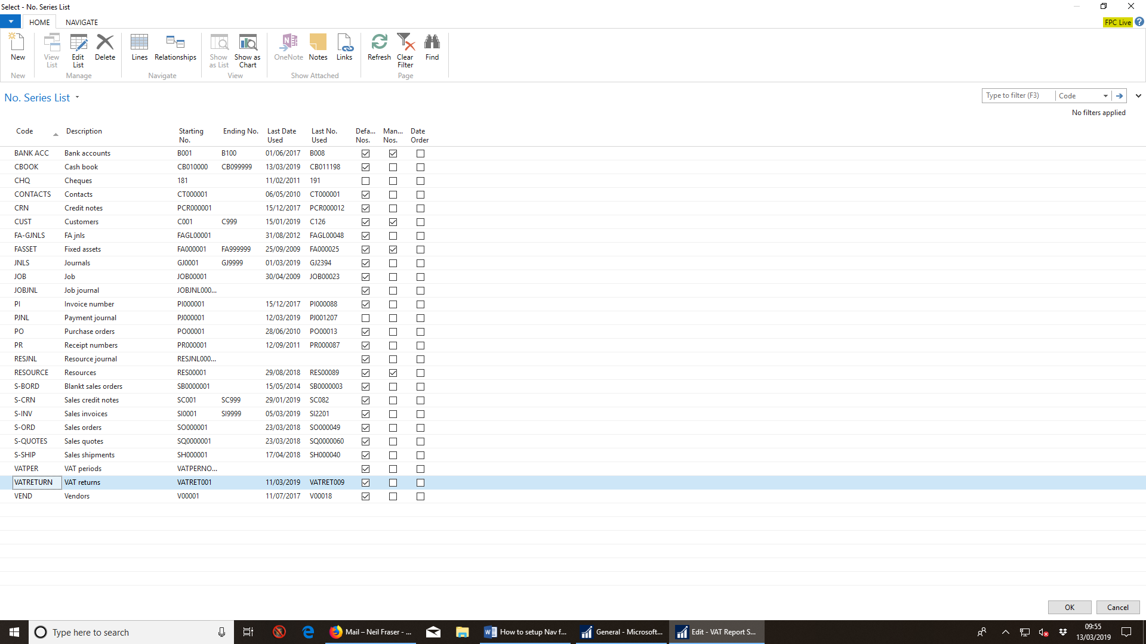
  - VAT return period number series
    - Assign a number series which will then be used when a VAT return is created.
    - If you have not created a number series for this task, create one in the usual way.
  - Once complete the fast tab Numbering should look as follows:

- Complete the fast tab Return Period as follows:
  - Confirm report version – this comes from the VAT Report Configuration Setup above.
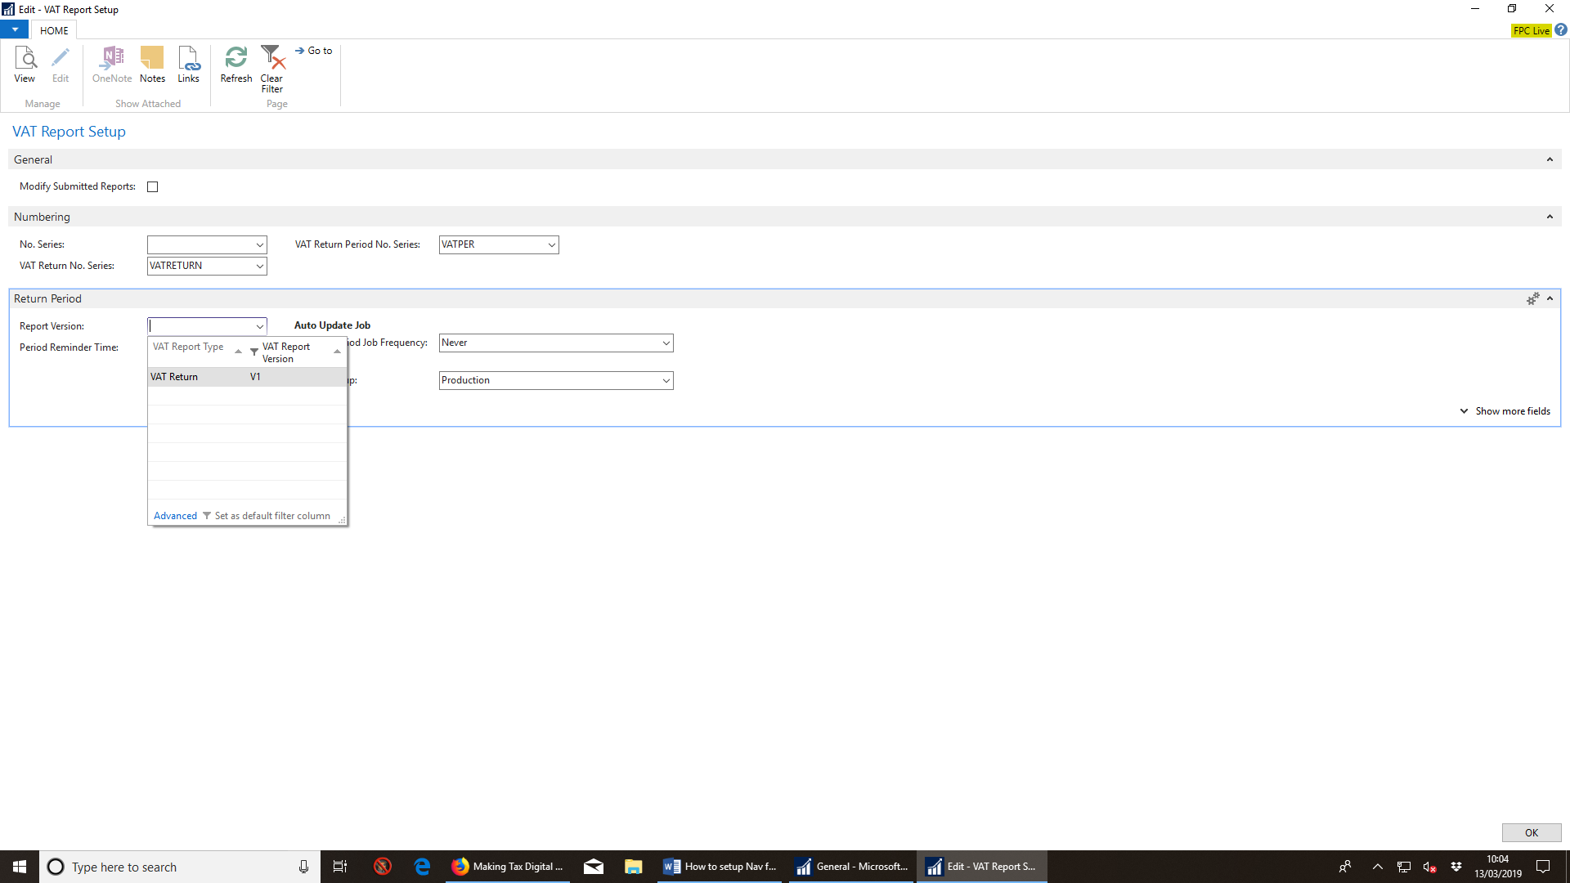
  - Leave all other fields as is.

VAT period set up
- Navigate to Departments, Financial Management, Periodic Activities.
- Select VAT and then VAT Return Periods.
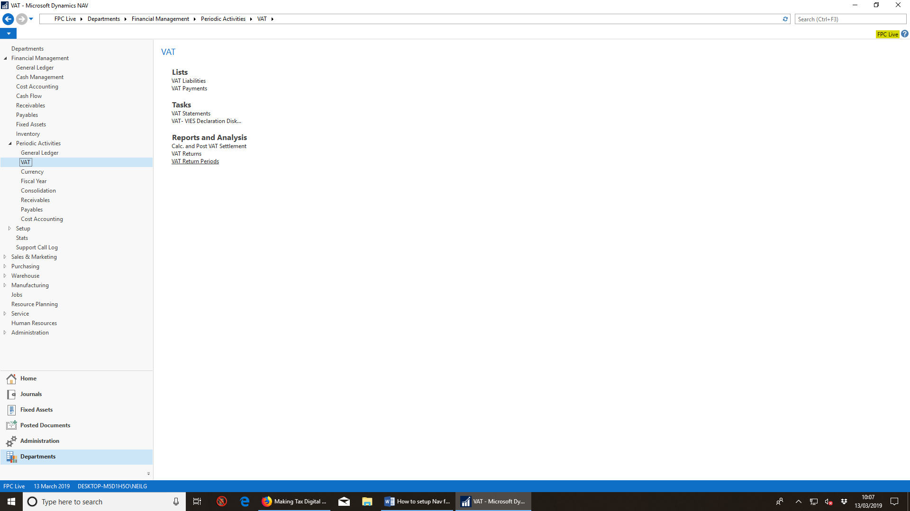
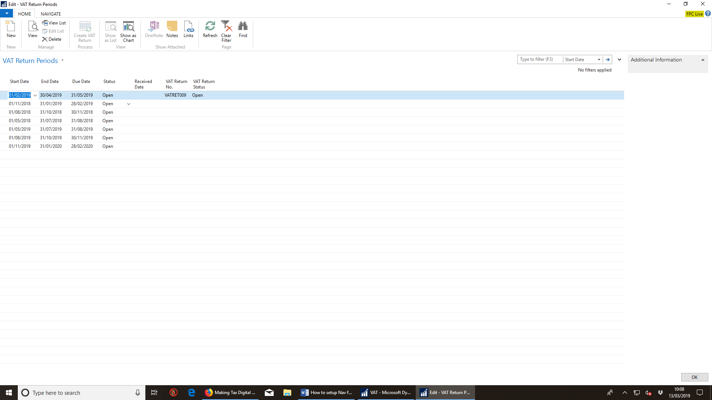
- Confirm your VAT return quarter ends.
  - For the sake of completeness and testing we have created VAT return quarters going back 12 months and forward 12 months. We will only be submitting MTD VAT returns for current quarters after go live.
- By far the best way to create a VAT return for a quarter selected is to highlight the relevant VAT quarter end and select Create VAT Return. Much easier!
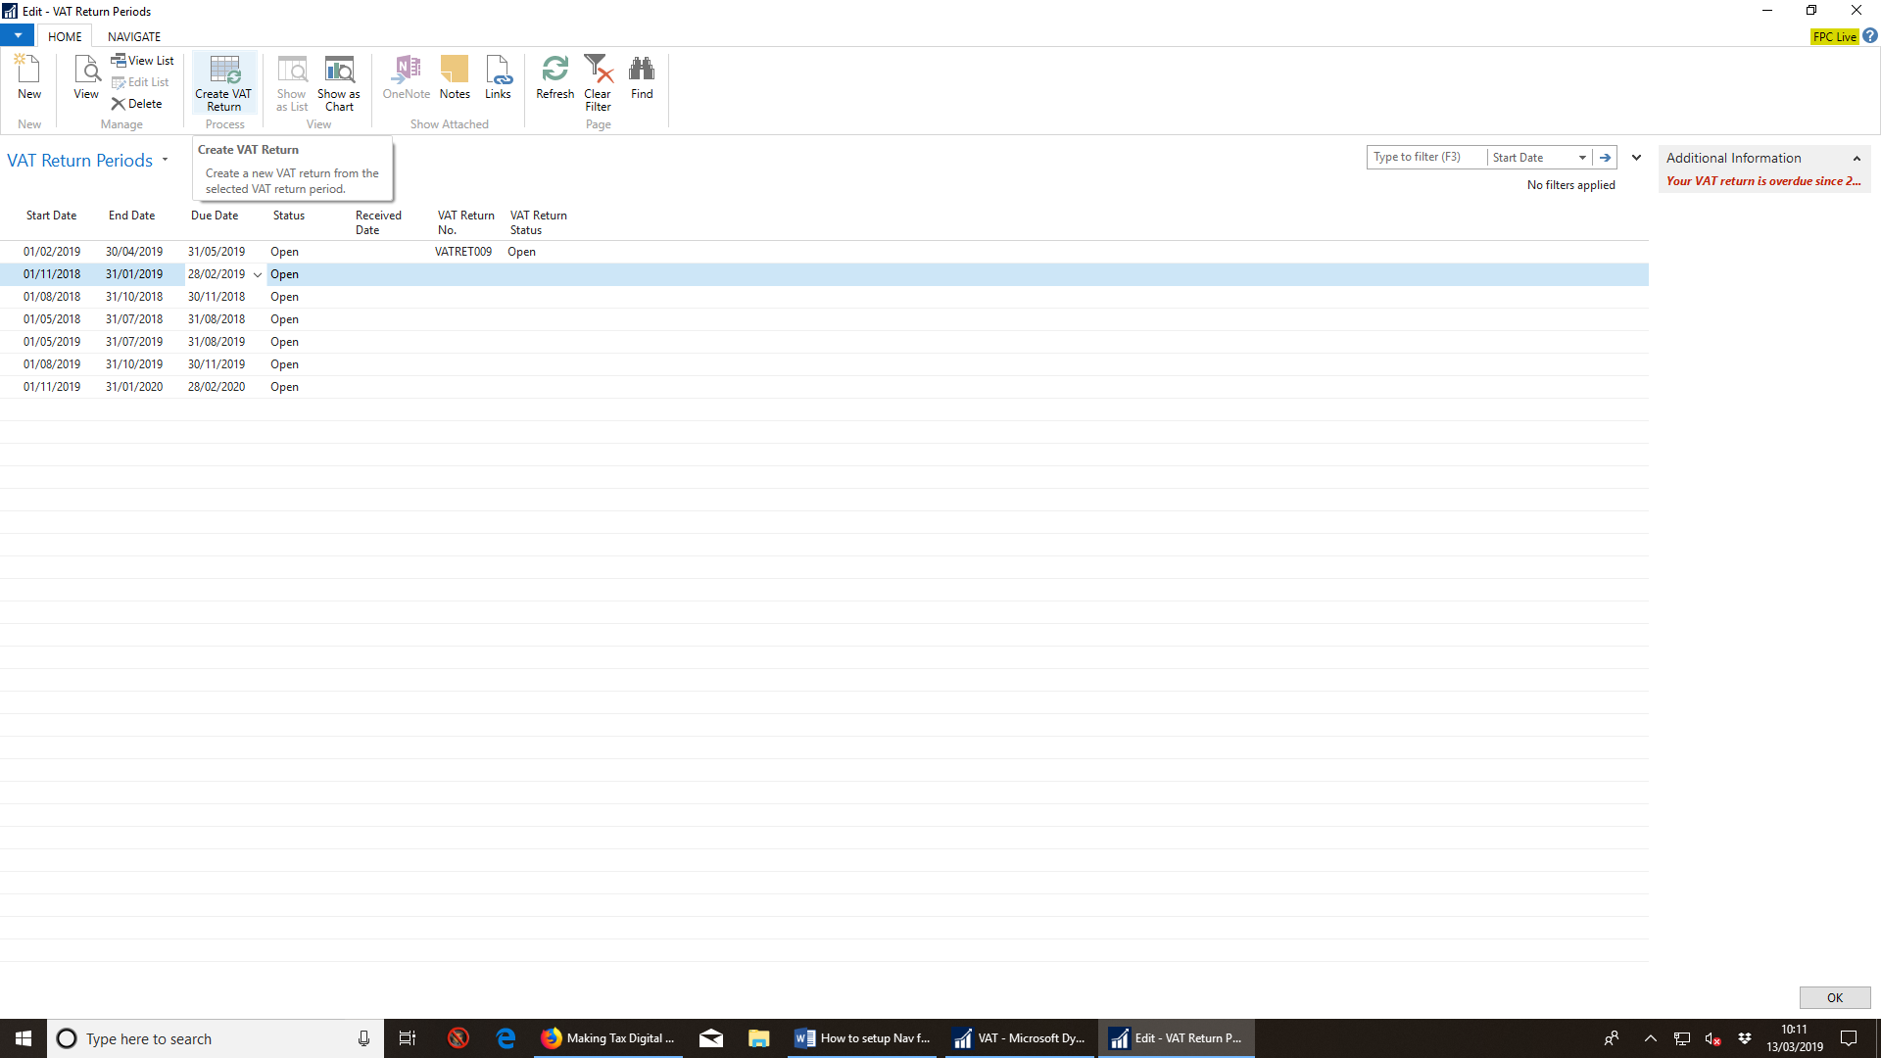

Next…..
To follow on the next document:
- Configuring GovTalk or OAuth.
- Request authorisation.
- Test.
- Submit first VAT return under MTD VAT to HMRC.

